Ostomy Day Stoma Clinic & Vendor Fair
Monday, October 5th, 2026 5 pm-8 pm
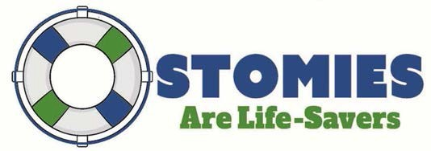

Location: St. Luke’s Doctors Building Atrium
224 S Woods Mill Rd, Chesterfield, MO 63017
Come get your stoma evaluated FREE
by a certified ostomy nurse in a 20-minute session.
Sign up at uoaastl.org
Walk-ins will be accommodated upon availability

Check out the products available at our Vendor Fair and Supply Pop-up Shop

