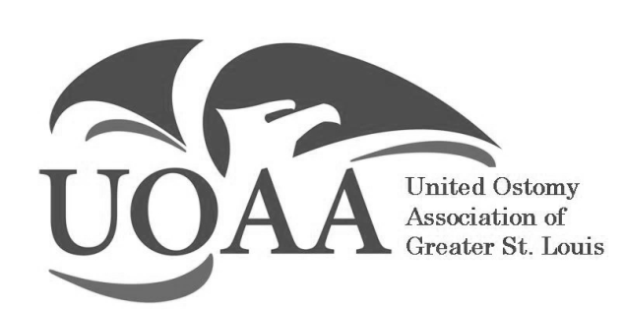

ANNUAL BANQUET

Monday, December 7th, 2026

Syberg’s
Dorsett
I-270 at Old Dorsett Road

2430 Old Dorsett Rd.
Maryland Heights, MO 63043

6:30-9:00 PM

$30.00 per person Cash, Check or Debit/Credit can be used via PayPal at
www.Paypal.me/uoastl
UOASL is subsidizing some of the price to keep it at $30.
Buffet Dinner / Cash Bar
Door Gifts, 50/50 and Raffles
********************************************
Return this bottom portion to:
Michele Harris
527 Candle Light Lane
Hazelwood, MO 63042
Check payable to UOASL - RSVP by Nov. 27th, 2026

Name: ______________________________

Phone Number: _______________________

Number of people: _____ X $30.00 = ____enclosed

